**WEEK-3**

**Exercise 1: Configuring a Basic Spring Application & Exercise 2: Implementing Dependency Injection**

|  |  |
| --- | --- |
| pom.xml  <project xmlns="http://maven.apache.org/POM/4.0.0"           xmlns:xsi="http://www.w3.org/2001/XMLSchema-instance"           xsi:schemaLocation="http://maven.apache.org/POM/4.0.0                               http://maven.apache.org/xsd/maven-4.0.0.xsd">      <modelVersion>4.0.0</modelVersion>      <groupId>com.library</groupId>      <artifactId>librarymanagement</artifactId>      <version>1.0-SNAPSHOT</version>      <properties>          <maven.compiler.source>17</maven.compiler.source>          <maven.compiler.target>17</maven.compiler.target>      </properties>  <dependencies>          <dependency>              <groupId>org.springframework</groupId>              <artifactId>spring-context</artifactId>              <version>5.3.33</version>          </dependency>      </dependencies>  <build>          <plugins>              <plugin>                  <groupId>org.codehaus.mojo</groupId>                  <artifactId>exec-maven-plugin</artifactId>                  <version>3.5.1</version>                  <configuration>                      <mainClass>com.library.Main</mainClass>                  </configuration>              </plugin>          </plugins>      </build>  </project> | applicationContext.xml  <?xml version="1.0" encoding="UTF-8"?>  <beans xmlns="http://www.springframework.org/schema/beans"         xmlns:xsi="http://www.w3.org/2001/XMLSchema-instance"         xsi:schemaLocation="http://www.springframework.org/schema/beans                             http://www.springframework.org/schema/beans/spring-beans.xsd">      <bean id="bookRepository" class="com.library.repository.BookRepository"/>      <bean id="bookService" class="com.library.service.BookService">          <property name="bookRepository" ref="bookRepository"/>      </bean>  </beans> |
| BookRepository.java  package com.library.repository;  public class BookRepository {      public void saveBook(String bookName) {        System.out.println("Book saved: " + bookName);      }  } | BookService.java  package com.library;  import org.springframework.context.ApplicationContext;  import org.springframework.context.support.ClassPathXmlApplicationContext;  import com.library.service.BookService;  public class Main {      public static void main(String[] args) {          ApplicationContext context = new ClassPathXmlApplicationContext("applicationContext.xml");          BookService bookService = (BookService) context.getBean("bookService");            bookService.addBook("Harry Potter");          bookService.addBook("Data Structures in Java");      }  } |

|  |
| --- |
| Main.java  package com.library;  import org.springframework.context.ApplicationContext;  import org.springframework.context.support.ClassPathXmlApplicationContext;  import com.library.service.BookService;  public class Main {      public static void main(String[] args) {          ApplicationContext context = new ClassPathXmlApplicationContext("applicationContext.xml");          BookService bookService = (BookService) context.getBean("bookService");            bookService.addBook("Harry Potter");          bookService.addBook("Data Structures in Java");      }  } |

**OUTPUT:**

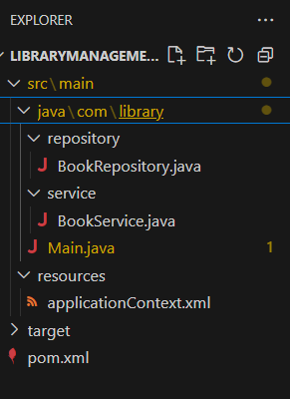

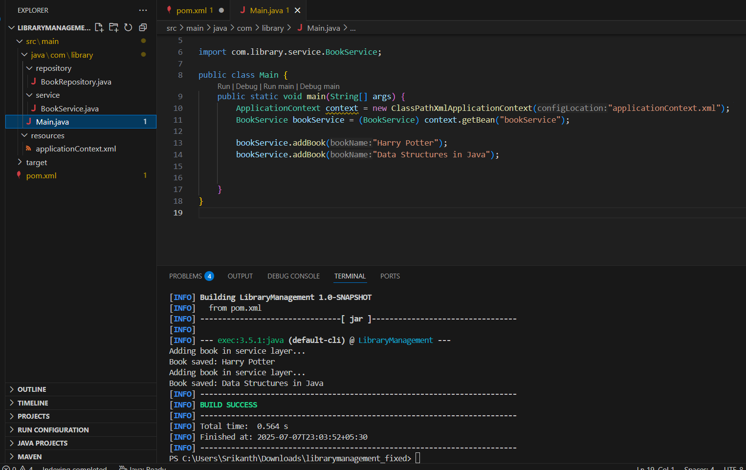

**Exercise 4: Creating and Configuring a Maven Project**

|  |
| --- |
| Pom.xml  <project xmlns="http://maven.apache.org/POM/4.0.0"           xmlns:xsi="http://www.w3.org/2001/XMLSchema-instance"           xsi:schemaLocation="http://maven.apache.org/POM/4.0.0                               http://maven.apache.org/xsd/maven-4.0.0.xsd">        <modelVersion>4.0.0</modelVersion>      <groupId>com.library</groupId>      <artifactId>LibraryManagement</artifactId>      <version>1.0-SNAPSHOT</version>      <dependencies>          <dependency>              <groupId>org.springframework</groupId>              <artifactId>spring-context</artifactId>              <version>5.3.33</version>          </dependency>          <dependency>              <groupId>org.springframework</groupId>              <artifactId>spring-aop</artifactId>              <version>5.3.33</version>          </dependency>          <dependency>              <groupId>org.springframework</groupId>              <artifactId>spring-webmvc</artifactId>              <version>5.3.33</version>          </dependency>      </dependencies>      <build>          <plugins>            <plugin>              <groupId>org.apache.maven.plugins</groupId>              <artifactId>maven-compiler-plugin</artifactId>              <version>3.11.0</version>              <configuration>                  <source>1.8</source>                  <target>1.8</target>              </configuration>          </plugin>            <plugin>              <groupId>org.codehaus.mojo</groupId>              <artifactId>exec-maven-plugin</artifactId>              <version>3.5.1</version>              <configuration>                  <mainClass>com.library.Main</mainClass>              </configuration>          </plugin>      </plugins>      </build>  </project> |

**OUTPUT:**

